Outline

1. Intro
   1. Introduce topic
   2. Define components
   3. Establish reason and credibility
   4. Give rough outline as to direction of paper
2. Processors
   1. What they do
      1. Sends signals to other pieces of hardware
      2. The brain of the computer
      3. Computer cannot function without the cpu
   2. What they look like
      1. 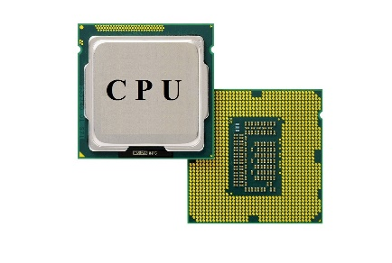
      2. 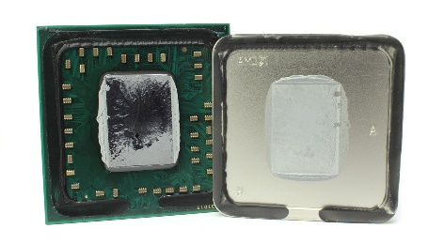
   3. Components
      1. Microprocessor
         1. Integrated circuit containing all functions of cpu
      2. Transistors
         1. The logic gates of the processor, hold Boolean 0’s and 1’s
   4. Cooling
      1. All processors need to be cooled.
      2. Most air cooled but extreme rigs use ‘water’
         1. Custom water loop versus AIO
   5. Cores and threads
      1. A core is an independent processing unit on the chip, able to read and execute programs either together or independently
      2. a thread of execution is the smallest sequence of programmed instructions that can be managed independently by a scheduler, which is typically a part of the operating system.
   6. Chipsets, registers cache
      1. Chipsets are different layouts of pins on the motherboard and CPU and they must align for it to work
      2. Register is a quickly accessible memory location on the actual CPU. Very small amount of fast storage
      3. Cache is also small memory (very fast) to reduce calls to main memory. Very close in relation to CPU core so quick memory retrieval. Multiple different levels of cache, usually three or so. As cache levels increase, cache size increases but speed decreases
   7. Market leaders and advancements
      1. Intel VS AMD
3. Motherboards
   1. What they do
      1. Main circuit board, holds CPU and allows communication to memory and peripherals. It is where everything plugs in at
   2. What they look like
      1. 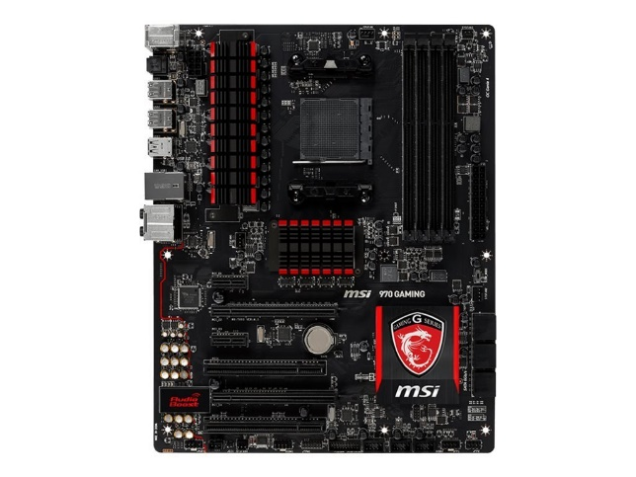
   3. Different plug ins all over
      1. 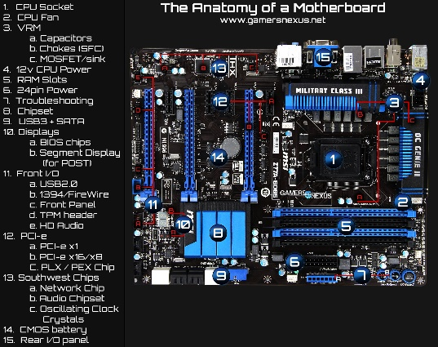
   4. Chipsets
      1. Like before, motherboard chipset **must** match the CPU chipset
   5. Market leaders and advancements
      1. Asus, MSI, EVGA, Gigabyte, ASRock, Acer, Intel, Apple, Dell
   6. Busses
      1. Communication system that transfers data between components
   7. Input/output
      1. All motherboards contain the input and output jacks. Display, network, USB, audio,
4. Random access memory
   1. What it does
      1. Computer data storage that stores information currently being used. Moderately fast read and write speeds but what cannot be handled in the cache gets pushed to RAM
   2. What it looks like
      1. 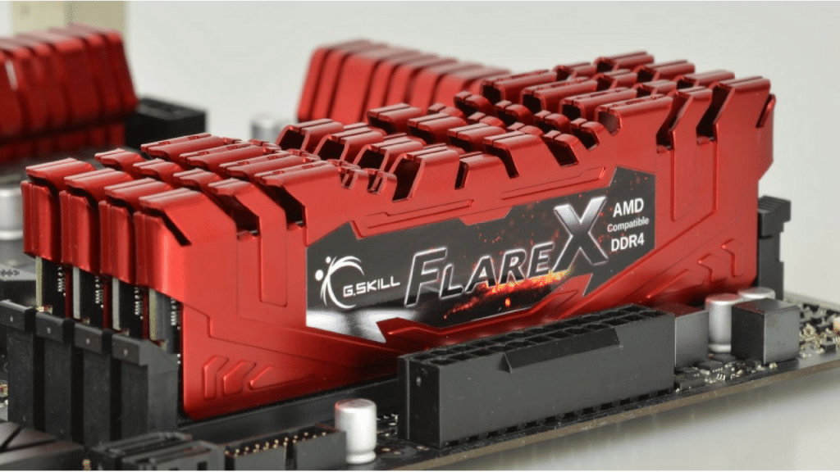
   3. Types
      1. SRAM vs DRAM
   4. Capacity
      1. Normal computers have around 8 Gb of ram but high end PC’s can have up to 128 Gb (one system on Beocat has 1 Tb)
   5. Speed and timing
      1. Recent advancements have brought DDR4 (started with DDR1)
      2. Ram speed is the measured data transfer rate in Mhz
      3. Timing measures the specific amount of time it takes to access a single bit of data in the memory array.
   6. Market leaders and advancements
      1. Samsung, SK Hynix, Micron Group, Nany, Winbond
5. Storage
   1. What it does
      1. Stores all your files and operating system
      2. Keeps your data after turning off your pc (unlike RAM and cache)
   2. What it looks like
      1. Hard drive 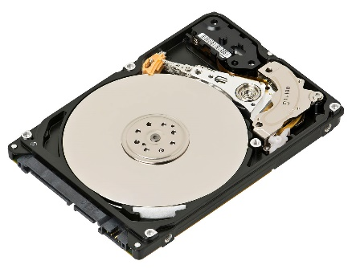
      2. Solid state drive 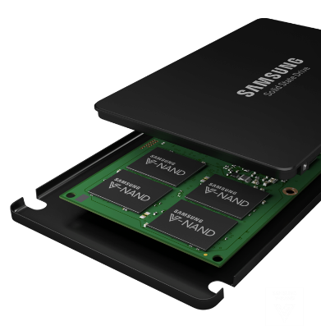
   3. Different type (mechanical versus solid state)
      1. HDD – uses magnetic storage using rotating disks and read and written by a moving actuator arm
      2. SSD – uses integrated circuit assemblies to store data
   4. Capacity vs cost
      1. HDD – normally very cheap
         1. 1 Tb HDD is around $50
      2. SSD – very expensive as the technology is rather new
         1. 1 Tb SSD is around $200
   5. Speeds
      1. HDD between 20 and 120 MB/s
      2. SSD between 200 and 500 MB/s
   6. How to connect it to the motherboard
      1. SATA cable
   7. Market leaders and advancements
      1. Samsung, Seagate, Western Digital, Kingston, SanDisk, Team Group
6. Power supply
   1. What it does
   2. What it looks like
   3. Different types (modularity)
   4. Wattage output
   5. How to connect it with the rest of the comptuer
   6. Market leaders and advancements
7. Graphics cards
   1. What it does
   2. What it looks like
   3. Enterprise versus gaming versus mining
   4. Capacity and capability
   5. Market leaders and advancements
8. Cooling and cases
   1. Air versus water
   2. What needs cooled
   3. Fan types
   4. Case designs and impact on cooling
9. Installation
   1. Step by step guide to building a custom computer
   2. Help the reader understand what component goes where
   3. How to plug everything in
10. Conclusion
    1. Wrap up